Hide/Unhide Help-Construction objects (HilfsKonstruktion):
Hides / unhides Help Construction objects i.e.: HK Detail- and ModelLines ,
HK TextNotes, HK Dimensions. Latter are identified by letters „HK“ in their FamilyTypeName.
pdfOut_Sheets:
exports multiple Drawing Sheets to pdfs, with papersizeformat matching each sheet format. Filename gets created from sheet parameters. Sheets can be selected either in the Project Browser before running the command or from Sheet-Selection-dialog, popping up when run.
pdfOut_SheetSet:
Same functionality as pdfOut_Sheets, only that sheets contained in a ViewSheetSet get exported.
Create SheetSet fr. Selection:
This tool creates a user named View/SheetSet object in Revit Database containing selected sheets. Selection is made either from Project Browser or Sheet-Selection-dialog.
dwg/dxf Export:
fast dwg/dxf-file export of multiple sheets. Filename specified from sheet parameters. Same functionality as pdfOut_sheets, but as dwg-files.
Sheets from Excel:
fast creation of sheet objects in Revit Database from Excel-table.
Layout Border- and Sheet-Header type are identified by name and are created. Values for parameters Sheet Name, Sheet Nr, Drawn by and Sheet Issue Date of each sheet object can be set.
Prj-Info from Excel:
not implemented yet
Levels from Excel:
not implemented yet

PyRevit:
PyRevit is an Addin for Autodesk Revit which makes IronPython scripts available for accessing the Revit API. It was created and is maintained by Ehsan Iran-Nejad. On his github page https://eirannejad.github.io/pyRevit he defines pyrevit as:
„pyRevit is an IronPython script library for Revit. However, it is not really written as an example library. It is a working set of tools fully written in IronPython that explores the power of scripting for Revit and also adds some cool functionality.“ [https://eirannejad.github.io/pyRevit/whatspyrevit]
Further information can be found his webpage, see the provided links.

In depth look at the pdf_Sheet_Export tool:

Motivation:
Revit pdf exporting functions are very limited. There are 2 ways, Sheetviews can be exported:
1. For each Sheet the user wants to export he has to manually choose a PaperSize-Format specified in the SheetSetting-Dialog. User defined filenaming with sheet parameters is not supported. As default filename the projectname is provided. Exported pdfs have to be renamed manually afterwards.
2. View/SheetSet export
SheetViews can be saved in a set and the set print.
Other CAD programs pdf
This is unconvenient.
There are a lot of addin tools on the appshop which provide functionality, they are all missing the right papersize
Dynamo Solution, Print pdf Node by Konrad Salomon, archilab.net package. On his Blog he describes , First thing users in Dynamo want is pdf export functionality.
Allplan has this tools, User Wish in Revit Ideas

pdfOut_sheets tool:
The pdfOut_sheets tool exports:
- multiple Revit Sheets to pdf at the same time,
- with filenames specified by sheet parameters for each sheet, i.e.
„SheetNumber_Revision_SheetName_date_time“
(ex: “A01_b_Floorplan L00_17.06.18_11:34.pdf“ ).
- with papersize format automatically matching the sheetsize format
- Sheetview selection is made either by selecting Sheets in Project Browser before the script is run or by Sheet-Selection-Dialog (Fig. 1).
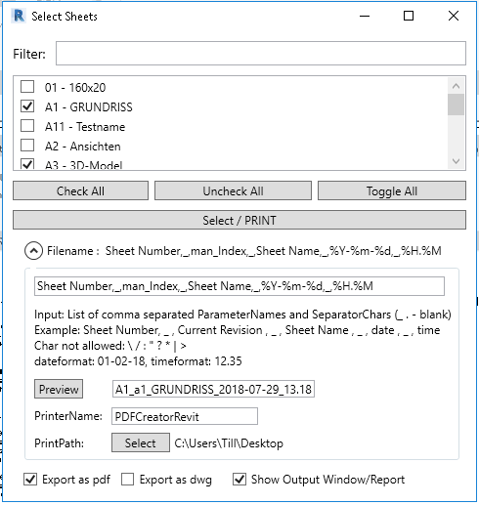
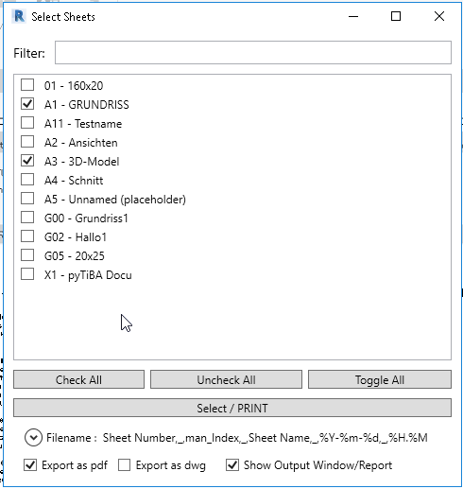Fig. 1: Sheet Selection Dialog

Rough outlines on how the script works:

Sheet Selection / Sheet Selection Dialog:
Sheet selection is made either by selecting sheets in the Revit-projectbrowser and running the script or by selecting sheets in the Sheet-Selection-Dialog.
Either way the RevitAPI-sheetview-objects are saved in a python list called “viewlist”
The Sheet-Selection-Dialog is a customized version of the “SelectFromCheckboxes” Dialog which can be found in the pyrevitlib forms package. (pyRevit\pyrevitlib\pyrevit\forms\__init__.py
It uses the WPF (Windows Presentation Forms) GUI toolkit provided by the .Net Framework. (pyRevit is completely written in IronPython, the “Windows” Version of Python).
All user input that is done in the Dialog is saved in a python dictionary “dlgdic”. It contains the following key/value pairs:
>>> for i in dlgdic.iteritems(): print i
...
﻿('paranames', 'Sheet Number,_,man_Index,_,Sheet Name,_,date,_,time')
('printfilepath', 'C:\\Users\\Till\\Desktop')
('output', True)
('pdfexport', False)
('printername', 'PDFCreatorRevit')

Filenaming:
The User can specify a filename consisting of parameternames and separator letters divided by a comma in the filename textbox of the Sheet Selection Dialog. The parameternames have to be parameters that can be found in Revit Property dialog of the SheetView.
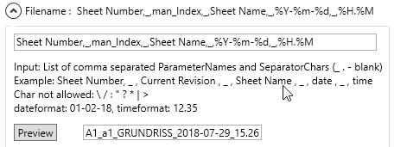
The textinput from the user in the filename-textbox is saved as a string and split into a list (paralist) with the builtin python split(‘,’) method (thats what the commas are for).
Filename creation is done by two funtions. The “namefromparalist” and the “pdfnamelist”-function
The “namefromparalist” function takes a view and the paralist as arguments. The function basically loops through the list, and looks up each parametername in the provided view. It extracts the parametervalue and builds a filename string by appending the values to one another. Separator letters are appended as well. The function returns the filename for the provided view.

def namefromparalist(view, paralist):
import datetime
m = datetime.datetime.now()
date = m.strftime("%d-%m-%y")
time = m.strftime("%H.%M")
tmp_filenamelist = []
for i in paralist:
if i in ['_', ' ', '.', '-', ';']:
tmp_filenamelist.append(i)
elif i in ["date", "time"]:
datetime = m.strftime(eval(i))
tmp_filenamelist.append(datetime)
elif i.startswith("%"):
try:
datetime = m.strftime(i)
tmp_filenamelist.append(datetime)
except: pass
elif lookupparaval(view, i):
lookupval = lookupparaval(view, i)
tmp_filenamelist.append(str(lookupval) if lookupval else '')
else:
tmp_filenamelist.append(i)
filename = ''.join(tmp_filenamelist)
return filename

def pdfnamelist(viewlist, paralist, dirpath = ''):
filepathlist = []
filenamelist = []
for v in viewlist:
tmpname = namefromparalist(v, paralist)
tmpname += ".pdf"
filenamelist.append(tmpname)
filepathlist.append(dirpath + "\\" + tmpname )
return (filepathlist, filenamelist)

dirpath = dlgdic["printfilepath"] # can be anything, gets overwritten
str2list = dlgdic["paranames"].split(",")

fnlist= pdfnamelist(viewlist, str2list, dirpath)

The pdfnamelist function takes the viewlist, str2list and a directorypath (dirpath) as arguments.
It applies the namefromparalist function to any view in the viewlist, creating a filename for each view.
It returns a filenamelist containing all the filenames.

Matching a PaperSizeFormat for each Sheet
The Revit API has a PrintManagerClass which has a Property called PaperSizes
This is a C# set datatype and contains all valid print sizes of the current selected printer in the active Revit project.
(Revit API is documented at http://www.revitapidocs.com or in the Revit SDK help files. Latter can be downloaded at the Autodesk Developer Network)
On Window OS print paper size forms can be added manually on a global basis to pdf printers. This is done in:
Windows ControlPanel/ AdministrativeTools/PrintManagement
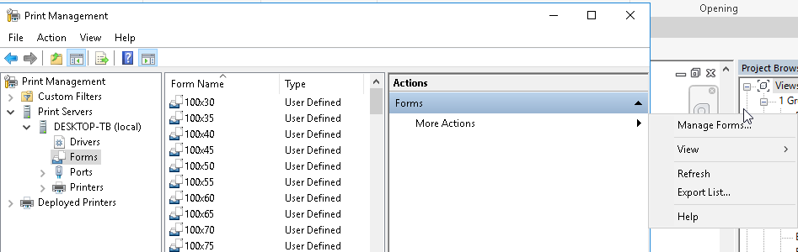
In the rightmost table one can click on More Actions>Manage Forms which opens the Print Server Property dialog.
If user defined forms are added they will be available to most installed pdf printers (PDFCreator, Adobe PDF, FoxitPhantom PDF, etc., they will NOT be available to some of the following printers: Microsoft Print to pdf, Print to OneNote, FreePdf).
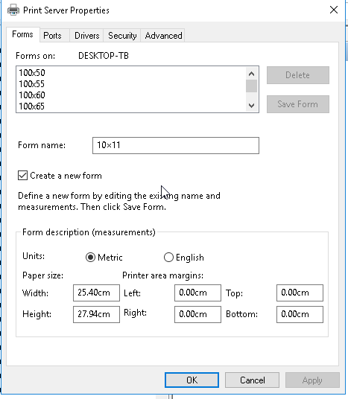

Those PrintPaper Sizes

This is just on possible way to do it.
A better way would be to access the API of a pdf_printer to change papersizes in for each print submitted. the ghostscript internaly.

Windows ControlPanel/AdministrativeTools/PrintManagement/ Forms

- The sheet Selection Sheet objects are saved in list: viewlist.
- Getting the Filenames with filename Function:
The filename function iterates over the viewlist. For each sheetview sheetparameters objects are collected and their values extracted. They are turned into strings and concatenated in user specified way. The concatenated string is saved in a filenamestring and appended to a list named filenamelist. It gets returned by the filename-function.
- Matchpapersize function: In order to provide the right papersize one firstl needs the sheet sizes. They can be retrieved from the title block family. The parameters are sheet width and sheet height. They are read only (greyed out in the properties panel)
Secondly one needs the papersize-formats. In the Revit API there exists a
- Print function: takes 1 view and 1 filename , 1 papersize object.

